The OSI Reference Model (Part 1)

Layers: (Please do not throw sausage pizza away)

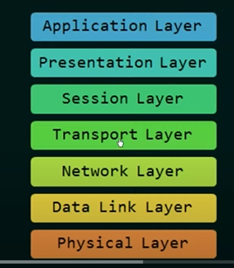

Order of the layers is very important.

